Experiment -1

**Aim – To create a static web page using different tags of HTML**

**Code-**

<!DOCTYPE HTML>

<!DOCTYPE html>

<html>

<head>

<title>My Webpage 1</title>

</head>

<body style="text-align:center;background-color:Tomato;">

<h1 st><em>This web page displays use of tags in HTML</em></h1>

<h2>This is a heading of category h2</h2>

<p>This is a tag used to show content as paragraphs </p>

<h3><i>Thank You</i></h3>

</body>

</html>

**Output-**

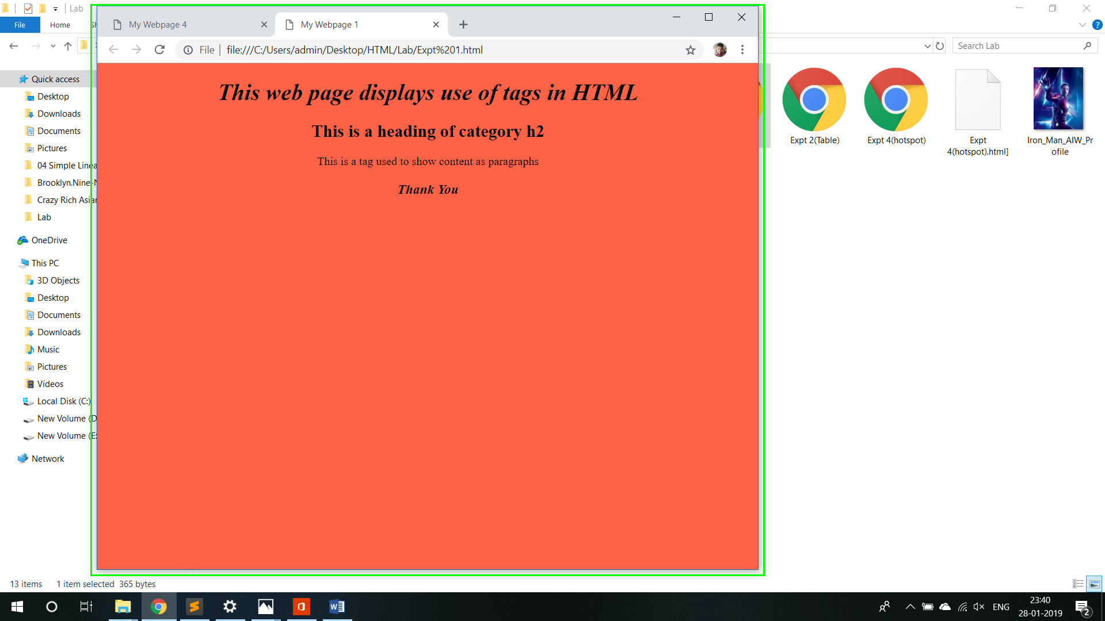

Experiment -2

**Aim – To create a HTML web page using TABLE tag**

**Code-**

<!DOCTYPE html>

<html>

<head>

<title>My Webpage 2</title>

</head>

<body style="background-color:Tomato;">

<h1>My Webpage 2</h1><br>

<h3>This is a table based on Student details</h1>

<table style="background-color:DodgerBlue;padding:5px;border:solid;text-align:left" >

<tr>

<th>First Name</th>

<th>Last Name</th>

<th>Department</th>

</tr>

<tr>

<td>Abhishek </td>

<td>Gupta</td>

<td>IT</td>

</tr>

<tr>

<td>Abhimany</td>

<td>Roy</td>

<td>CSE</td>

</tr>

<tr>

<td>Akash</td>

<td>Ratnani</td>

<td>Electrical</td>

</tr>

</table>

</body>

</html>

**Output-**

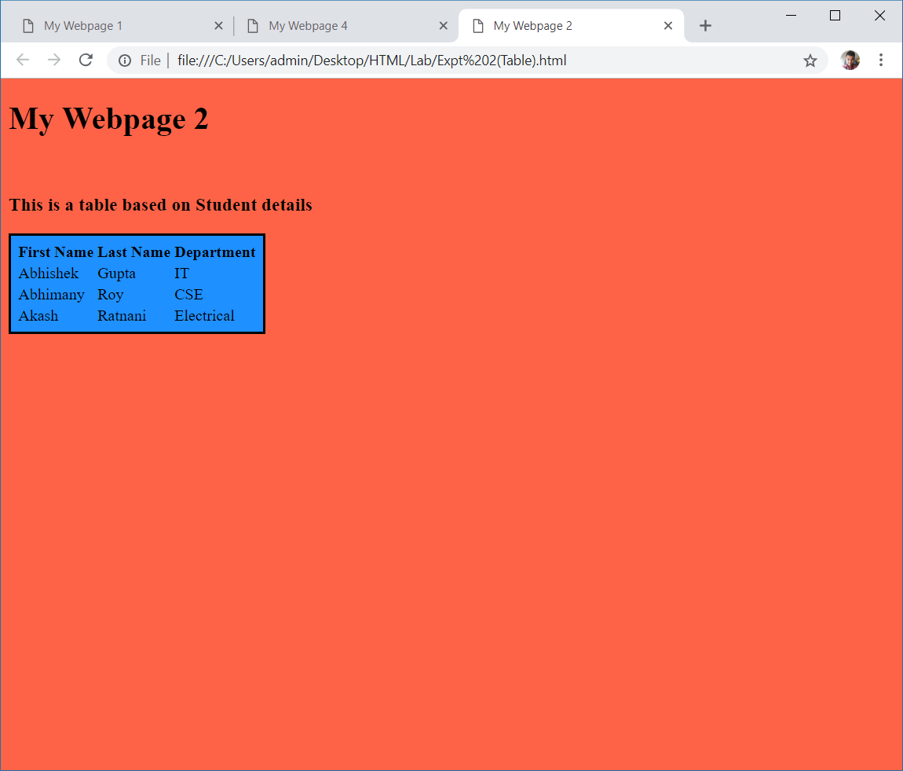

**Experiment -4**

**Aim – To create a web page of HTML**

* **To embed an image in the web page**
* **To fix hotspots**

**Code-**

<!DOCTYPE html>

<html>

<head>

<title>My Webpage 4</title>

</head>

<body style="font-family: serif;background-color: DodgerBlue">

<h1>A V E N G E R S A S S E M B L E ! </h1><br><br>

<h1 >You must click on different characters !!</h1>

<img src="avengers-1.jpg" alt="Avengers pic" usemap="#Map" />

<map name="Map" id="Map">

<area alt="" title="tony" href="Iron_Man_AIW_Profile.jpg" shape="poly" coords="242,114,297,98,324,158,389,149,457,60,524,105,436,208,392,233,400,299,405,355,433,432,432,460,283,466,252,433" />

<area alt="" title="hawk " href="4833767-7500117847-Hawke.jpg" rel="img" shape="poly" coords="180,171,217,185,209,227,229,254,236,325,208,333,212,460,93,396,124,269,125,235" />

<area alt="" title="thor" href="6093596-mcu+thor.jpg" shape="poly" coords="618,78,667,97,686,148,743,180,798,459,548,461,530,419" />

<area alt="" title="cap" href="Avengers_Infinity_War_poster_012_Textless.jpg" shape="poly" coords="572,72,592,73,596,133,560,268,522,207,522,152,531,120" />

<area alt="" title="nick" href="nickfury-promocatwsjpg.jpeg" shape="poly" coords="423,228,439,229,440,244,473,257,477,281,468,336,438,402,416,356,406,267" />

<area alt="" title="nat" href="4833768-6580957710-Aveng.jpg" shape="poly" coords="496,236,520,228,540,252,558,292,537,369,523,411,521,460,496,464,481,405,456,415,454,390" />

<area alt="" title="hulk" href="download.jpg" shape="poly" coords="140,0,177,4,181,10,286,32,332,92,332,109,295,95,265,92,239,108,236,140,232,171,226,179,187,160,162,141,136,25,137,4" />

</map>

</body>

</html>

**Output-**

Hotspots



Final Webpage-

